This documentation will tell you what features the presets have by example.
If you have any questions, write to Kiryl, our analyst.

Preset Options in action order:
1. table wrapper
Responsible for wrapping certain tags with the <table> tag. It creates special structure inside <table>, and that's why it's different from the usual wrapper
Before:
<p>Some text</p>

After:
<table><tbody><tr><td>Some text</tbody></tr><t/d></table>

Option description:
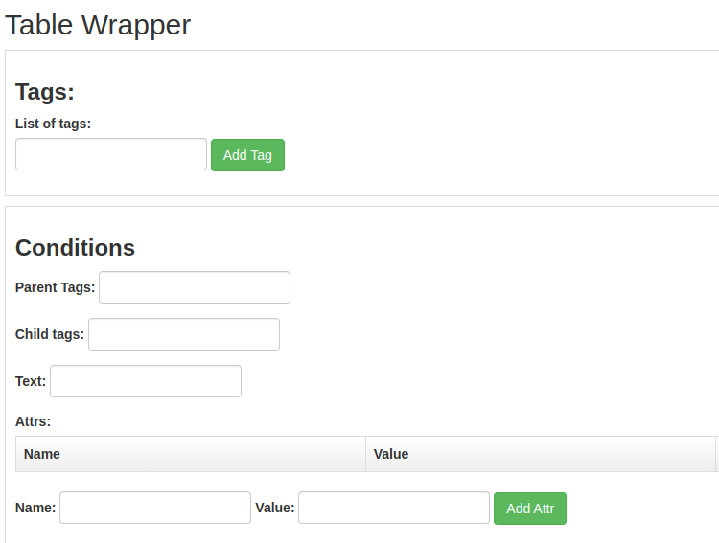

Fields:
- List of tags | Input: regex string | Example: ^section$ (Mandatory field)
- Conditions
  - Parent tags | Input: string with pseudo classes | Example: li
  - Child tags | Input: string with pseudo classes | Example: :not(:has(code, kbd, var))
  - Text | Input: regex string | Example: \\\\nonumber
  - Attrs
    - Name | Input: string | Example: class
    - Value | Input: regex string | Example: math-tex
________________________________________________________________________________

2. wrapper
Responsible for wrapping certain tags with another tag.
Before:
<strong>Some strong text</strong>

After:
<p><strong>Some strong text</strong></p>
Fields:
- List of tags | Input: regex string | Example: ^section$ (Mandatory field)
- Conditions
  - Parent tags | Input: string with pseudo classes | Example: li
  - Child tags | Input: string with pseudo classes | Example: :not(:has(code, kbd, var))
  - Text | Input: regex string | Example: \\\\nonumber
  - Attrs
    - Name | Input: string | Example: class
    - Value | Input: regex string | Example: math-tex
- Tag to wrap
  - Name | Input: string | Example: div (Mandatory field)
  - Attrs
    - Name | Input: string | Example: class
    - Value | Input: string | Example: b2
________________________________________________________________________________

3. decomposer
Responsible for decompose certain tags. Delete tag with all attributes that this tag contains.
Before:
<a href=”http://example.com/”>I linked to <i>example.com</i></a>
After:
<a href=”http://example.com/”>I linked to </a>

Option description:
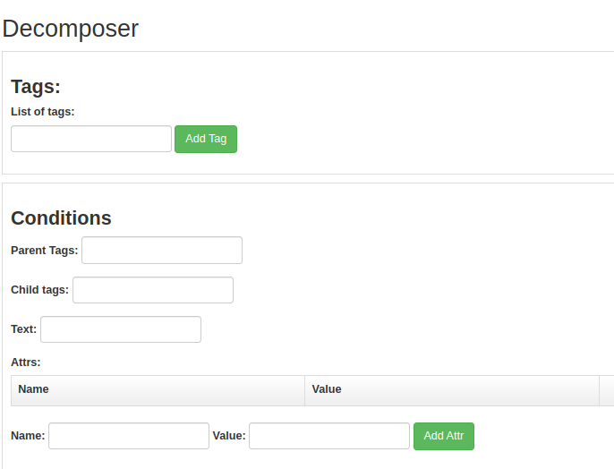

Fields:
- List of tags | Input: regex string | Example: ^section$ (Mandatory field)
- Conditions
  - Parent tags | Input: string with pseudo classes | Example: li
  - Child tags | Input: string with pseudo classes | Example: :not(:has(code, kbd, var))
  - Text | Input: regex string | Example: \\\\nonumber
  - Attrs
    - Name | Input: string | Example: class
    - Value | Input: regex string | Example: math-tex
________________________________________________________________________________

4. replacer
Responsible for replace certain tags with other tags.
Before:
<strong>Some strong text</strong>
After:
<i>Some strong text</i>

Option description:

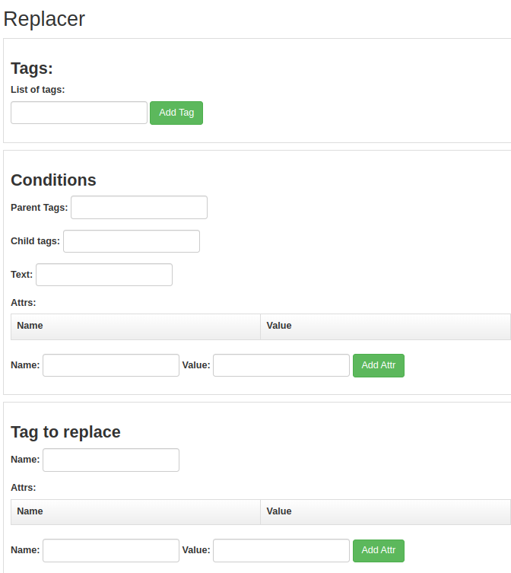

Fields:
- List of tags | Input: regex string | Example: ^section$ (Mandatory field)
- Conditions
  - Parent tags | Input: string with pseudo classes | Example: :is(li)
  - Child tags | Input: string with pseudo classes | Example: :not(:has(code, kbd, var))
  - Text | Input: regex string | Example: \\\\nonumber
  - Attrs
    - Name | Input: string | Example: class
    - Value | Input: regex string | Example: math-tex
- Tag to replace
  - Name | Input: string | Example: p (Mandatory field)
  - Attrs
    - Name | Input: string | Example: class
    - Value | Input: string | Example: b2
________________________________________________________________________________

5. attr_remover
Remove certain attribute from certain tag
Before:
<p age=”25”>Alex</p>
After:
<p>Alex</p>

Option description:
This option could:
- remove some text in attribute value
- remove attrs (attr.value in condtion should be empty in that case)
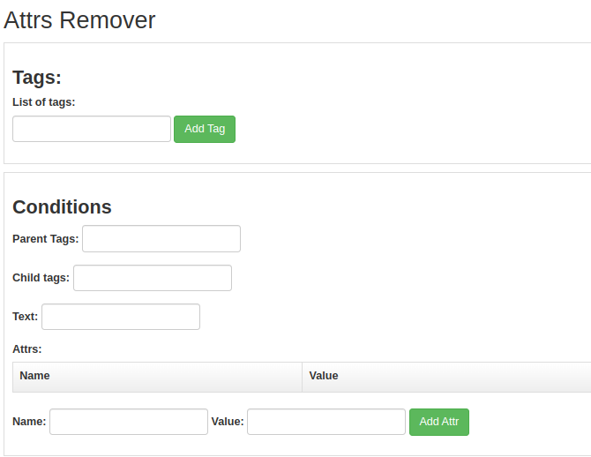
Fields:
- List of tags | Input: regex string | Example: ^sup$ (Mandatory field)
- Conditions
  - Parent tags | Input: string with pseudo classes | Example: :is(p)
  - Child tags | Input: string with pseudo classes | Example: :not(:has(code, kbd, var))
  - Text | Input: regex string | Example: \\\\nonumber
  - Attrs
    - Name | Input: string | Example: class
    - Value | Input: regex string | Example: math-tex
________________________________________________________________________________

6. attr_property_replacer
In this preset attrs condition is must have in some cases except 'add attr to empty tag'. The number of attributes in condition can be infinite, the main thing is that first attribute property is the one that we remove/replace.
This option could:
- replace property value
Before:
<pre style="margin-top:3px">aggData</pre>

After:
<pre style="margin-top:5px">aggData</pre>
- remove property from attr value
Before:
<pre style="margin-top:3px">aggData</pre>

After:
<pre style="">aggData</pre>

- replace property name
Before:
<pre style="margin-top:3px">aggData</pre>

After:
<pre style="margin-topic:3px">aggData</pre>

Option description:

Fields:
- List of tags | Input: regex string | Example: ^pre$ (Mandatory field)
- Conditions
  - Parent tags | Input: string with pseudo classes | Example: :is(p)
  - Child tags | Input: string with pseudo classes | Example: :not(:has(code, kbd, var))
  - Text | Input: regex string | Example: \\\\nonumber
  - Attrs
    - Name | Input: string | Example: style (Mandatory field)
    - Value | Input: regex string | Example: margin-top:3px (Mandatory field)
- Property to replace
  - Name | Input: string | Example: margin-top
  - Value | Input: string | Example: 33px
________________________________________________________________________________

7. attr_replacer
In this preset attrs condition is must have in some cases except 'add attr to empty tag'. The number of attributes in condition can be infinite, the main thing is that first attribute is the one that we replace.
This option could:
- add attr to tag
Before:
<div>Tag without any attributes</div>
After:
<div class=”_div”>Tag without any attributes</div>

- replace attr
Before:
<div class=”_div”>Tag without any attributes</div>
After:
<div new_class=”_div”>Tag without any attributes</div>

- change value of attr
Before:
<div class=”_div”>Tag without any attributes</div>
After:
<div class=”new_div”>Tag without any attributes</div>

Option description:
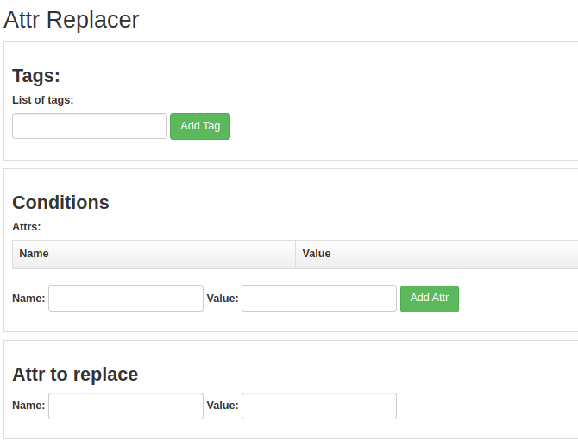

Fields:
- List of tags | Input: regex string | Example: ^img$ (Mandatory field)
- Conditions
  - Parent tags | Input: string with pseudo classes | Example: :is(p)
  - Child tags | Input: string with pseudo classes | Example: :not(:has(code, kbd, var))
  - Text | Input: regex string | Example: \\\\nonumber
  - Attrs
    - Name | Input: string | Example: xlink:href (Mandatory field)
    - Value | Input: regex string | Example: .*
- Attr to replace
  - Name | Input: string | Example: src (Mandatory field)
  - Value | Input: string | Example: b1
________________________________________________________________________________

8. unwrapper
Responsible for unwrapping certain tags. Unwrapper is similar to decomposer, but it sets tag attributes to the parent instead of removing them.
Before:
<section><div>Text</div></section>
After:
<section>Text</section>
Option description:
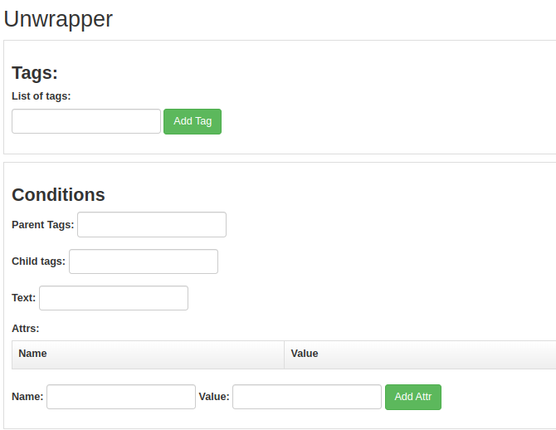
Fields:
- List of tags | Input: regex string | Example: ^sup$ (Mandatory field)
- Conditions
  - Parent tags | Input: string with pseudo classes | Example: :is(p)
  - Child tags | Input: string with pseudo classes | Example: :not(:has(code, kbd, var))
  - Text | Input: regex string | Example: \\\\nonumber
  - Attrs
    - Name | Input: string | Example: class
    - Value | Input: regex string | Example: math-tex
________________________________________________________________________________

9. inserter
Responsible for inserting certain tag in condition tags.
Before:
<section>Text</section>
After:
<section><div>Text</div></section>

Option description:
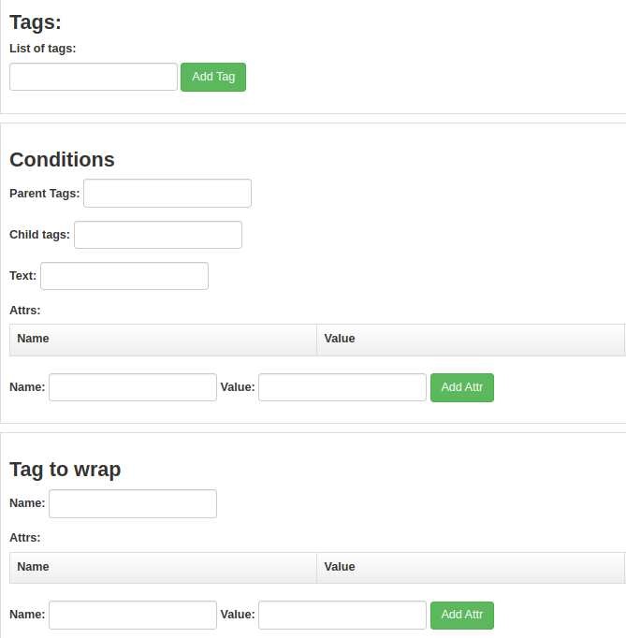
Fields:
- List of tags | Input: regex string | Example: ^h[1-5]$ (Mandatory field)
- Conditions
  - Parent tags | Input: string with pseudo classes | Example: :is(h1, h2, h3, h4, h5, h6)
  - Child tags | Input: string with pseudo classes | Example: :not(:has(code, kbd, var))
  - Text | Input: regex string | Example: \\\\nonumber
  - Attrs
    - Name | Input: string | Example: class
    - Value | Input: regex string | Example: math-tex
- Tag to insert
  - Name | Input: string | Example: strong (Mandatory field)
  - Attrs
    - Name | Input: string | Example: class
    - Value | Input: string | Example: really-strong
________________________________________________________________________________

10. text_replacer
Replace certain text on some text.
In this preset text condition is must have
Before:
<p>Curcose</p>
After:
<p>Purpose</p>

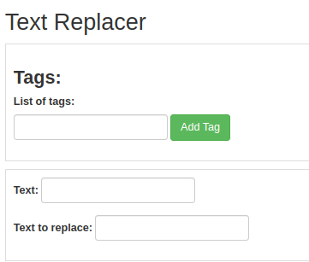
Option description:
Fields:
- List of tags | Input: regex string | Example: ^sup$ (Mandatory field)
- Conditions
  - Text | Input: regex string | Example: \\\\nonumber (Mandatory field)
- Text to replace | Input: string | Example: text

