frequent book errors
that cause converter error

Converter Error:
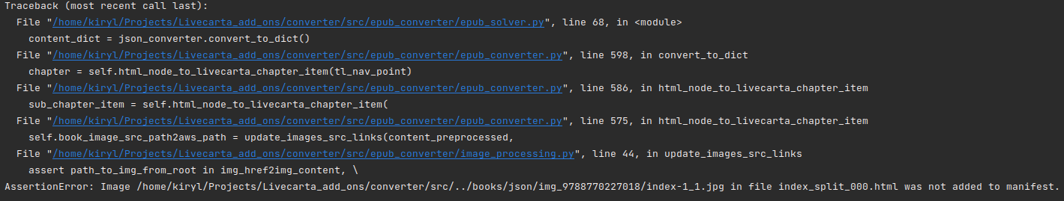
Cause in book:
one id corresponds to 2 hrefs and therefore this causes an error because the same part of the book goes through the converter twice. The converter prevents this so that there are no duplicate chapters and no overlapping of chapters
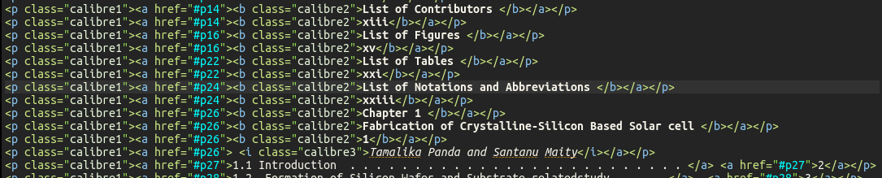
href=”#24” дважды и на 2-м фото id=”p24”

